Elicia Pluymers

Midterm Project Documentation

NEWM-N230

**Level Design Document**

**Working Title: Slingshot Kid**

[**Game Video Link**](https://drive.google.com/file/d/1osSzYQAsQ_RV-HviBbbIShUWpw-R5p78/view?usp=sharing)

**Game Identity / Mantra:**

Banish the spirits and help your friends. Two goals, one Slingshot.

**Design Pillars:**

Fun, Lighthearted First Person Shooter.

**Genre/Story/Mechanics Summary:**

You are a child who can see spirits that effect the world around you and no one else can see them. Your goal his to help your friends by stopping the spirits from causing issues and mayhem. You have a trusty slingshot that you use to shoot the enemies with magical spheres that make them return from where they came from.

**Before the level starts**

Your class at school has just been let out for recess and you realize that the playground has become overrun by Snail Spirits. Some or the slugs have already slithered onto your fellow classmates and are making them move very slowly or not at all.

**First Level Goal**

Your goal is to use your slingshot to send away all of the snail spirits on the playground.

You have speed spheres (electric blue orbs) to shoot the snails as they hate anything that moves quickly. Be careful though as there are still some snails moving around and if they touch you lose the game.

**Next Levels**

Each level would get progressively longer and take place in other locations, like in a classroom, at the player’s house. This level will only have one type of enemy, but as the game progresses, there would be different enemies, that would affect the world in different ways. With more types of enemies, the player would gain access to different types of projectiles that are able to banish different types of enemies. Each enemy will require a special type of projectile or need to be hit in a specific way to make them disappear.

**Features:**

Playground – The Merry Go Round Moves

* If you can get to the Merry Go Round you can stand on it and slowly spin to take out slugs all around you.

**Interface:**

Movement – WASD

Camera Movement - Mouse

Jump – Space

Pullout Slingshot – Q

Put Away Slingshot – Q

Aim – Hold E

Stop Aiming – Release E

Shoot – Left Mouse Button

**Art Style:**

The environment is meant to be animated and cartoon like. The colors should be bright as this is meant to be a light hearted game, not a gritty defeat the enemy type of game. It choose to use textures that did not have a huge amount of textures to more closely match the animations as well. The creatures will be varying colors based on how they affect the environment around them.

**Game Design Aspects and Decisions:**

Character – Animations

* I was able to use the Archer animations from Mixamo to design my character. The movements are very similar, I just gave my character a slingshot instead of a bow.

Other characters in the level - Movement

* Since the idea of the slugs is that they slow people down each character that has a slug attached to them is not able to move until, you free them. Then they move through the level as normal afterwards.

Snails – Movement

* I decided to have the snails not attached to people move in a circle around the merry go round making it harder to navigate through the space. Future levels can have additional creatures moving around, increasing the difficulty.

The Projectile – Energy Ball

* I deliberately set up the energy ball so it moves slower than an arrow or bullet. This is a small child with a slingshot so the speed should be slower. In addition to that since the projectile is actually a ball of energy it is not affected by gravity as it does not have real substance.
* I added a target symbol to the viewport widget so that it is easier to aim the slingshot.

**Further Development Opportunity:**

Projectile Aiming

* The aiming mechanism is workable, but slightly clunky. My attempt to restrict the angle you could rotate the camera while in the FPS mode, however there was an issue with the camera not following the player the right way after the first time you enter the FPS mode, so in the observance of time I had to cut that feature. If the bugs could be worked out it would be better for user experience.

Character Movement and Interaction

* Additional character development would help to make the game more engaging.
* Making the movement of the characters more fluid and potentially allowing some dialogue between the main player and the other characters would be a great addition.

Enemies That Follow You

* Creating more dynamic enemies that would chase the main player. Also enemies that could take damage instead of the one hit enemies in this first level

More interaction with the playground equipment

* The equipment is not climbable or usable right now other than the merry go round. It would be nice to see other characters interacting with the playground equipment while you move throughout the level.

**Music/Sound:**

There is currently no sound in the level, but in the future some sounds could be added.

Sounds like background noise of children playing, a sound for when the sling shot shoots a projectile, and a sound for when the snails are banished.

**Assets Included in the level**

Other Characters

* Girl Character and Animations

<https://www.mixamo.com/#/?page=1&query=amy&type=Character>

* Teacher Character and Animations

<https://www.mixamo.com/#/?page=1&query=claire&type=Character>

* Boy Character and Animations

<https://www.mixamo.com/#/?page=1&query=aj&type=Character>

Timmy Character and Animations

<https://www.mixamo.com/#/?page=1&query=timmy&type=Character>

* Slingshot

<https://www.cgtrader.com/free-3d-models/military/gun/slingshot-6480bdd2-76cf-4692-ab13-679a69de44ff>

Playground Equipment

* Merry Go Round

<https://www.turbosquid.com/3d-models/merry-go-round-x-3ds/531108>

* Swing Set Etc.

<https://www.turbosquid.com/3d-models/playground-play-max-free/982005>

* Wooden Bench

<https://www.turbosquid.com/3d-models/free-max-model-wooden-bench-table/884931>

Snail Enemy

<https://www.cgtrader.com/free-3d-models/animals/other/low-poly-snail-model>

Brick Wall Texture

<https://pixabay.com/illustrations/brick-brick-drawing-drawing-4956032/>

**Reference Images**

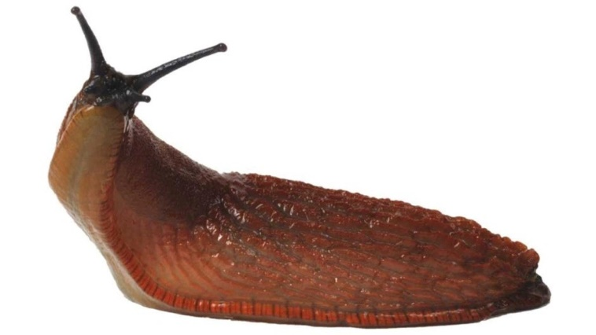**Enemy/Enemies**

Left to right

Slimy Slug – Initial Idea for the first spirit

<https://www.google.com/url?sa=i&url=https%3A%2F%2Fdepositphotos.com%2Fvector-images%2Fpixie-cut.html&psig=AOvVaw0vPb8lRo2wNZ3goukMLHoL&ust=1647049531777000&source=images&cd=vfe&ved=0CAsQjRxqFwoTCPjv5uv3vPYCFQAAAAAdAAAAABAP>

Spirit Fox – Adding effects so the enemies have emmisive colors and movement to their textures

<https://www.google.com/url?sa=i&url=https%3A%2F%2Fwallpapercave.com%2Fspirit-animals-wallpapers&psig=AOvVaw29-9PkpWIFPG1sdhL47Fb-&ust=1647049335514000&source=images&cd=vfe&ved=0CAsQjRxqFwoTCNCsjov3vPYCFQAAAAAdAAAAABAD>

Potential Second Enemy – Would knock over objects and cause mayhem

<https://www.google.com/url?sa=i&url=https%3A%2F%2Fwww.sciencefocus.com%2Fnature%2Fwhy-dont-slugs-have-shells%2F&psig=AOvVaw23wBld3LbJqka8bHpVryAG&ust=1647049072990000&source=images&cd=vfe&ved=0CAsQjRxqFwoTCMCy-4r2vPYCFQAAAAAdAAAAABAD>

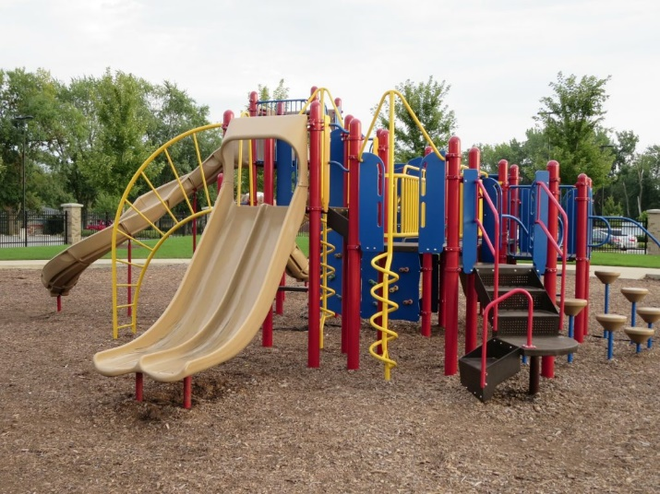**School Playground**

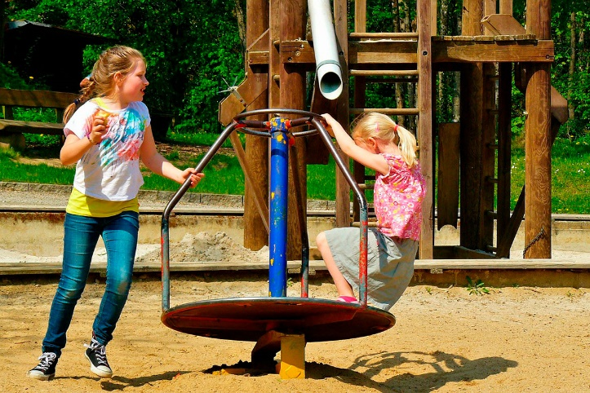

Left Playground

<https://www.primaryjunction.net/wp-content/uploads/2021/08/playground-182042_1920-1024x768.jpg>

Right Playground

https://www.aaastateofplay.com/media/page-images/free-guides/77-Reasons-Kids-Need-Playgrounds.jpg

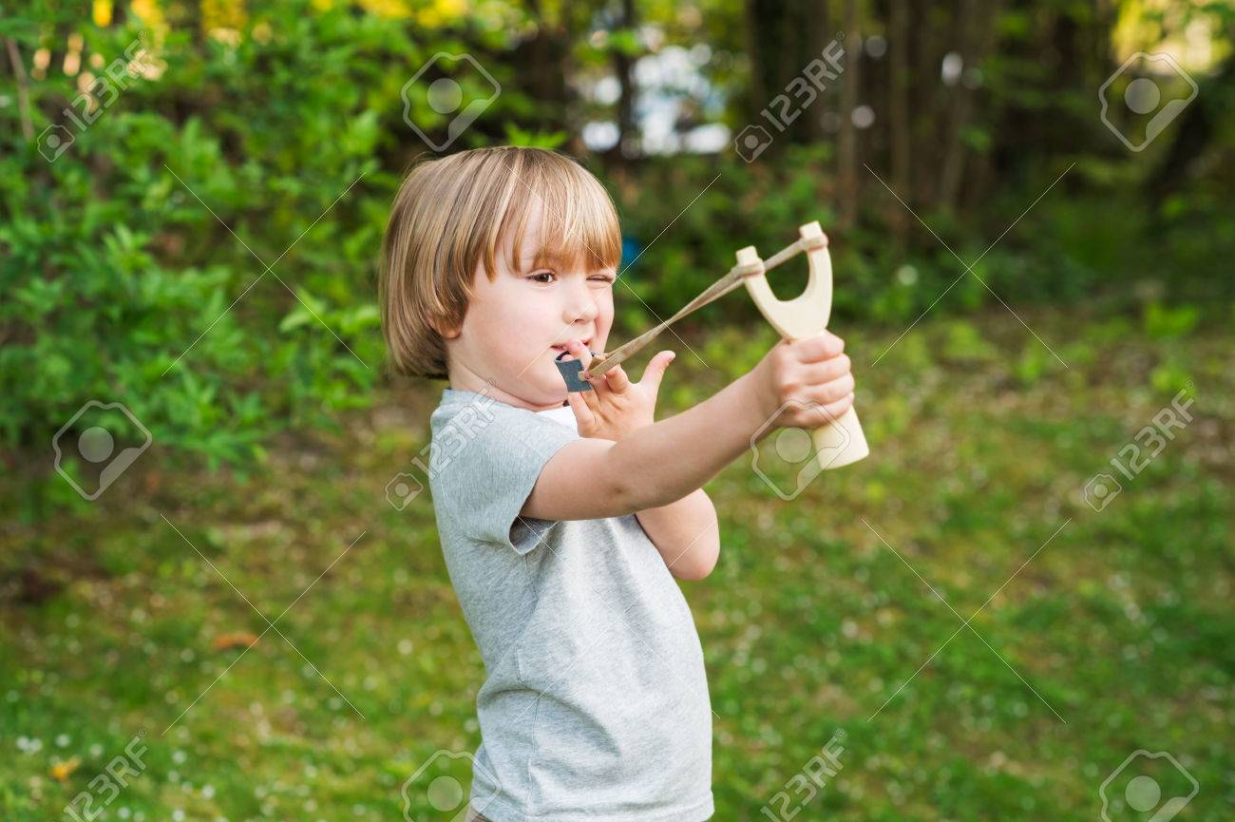**Timmy the Main Character**

Left Image

<https://previews.123rf.com/images/annanahabed/annanahabed1505/annanahabed150500062/39903518-ragazzino-sveglio-che-gioca-con-fionda-all-aperto.jpg>

Right Image

https://st.depositphotos.com/1732591/2800/v/950/depositphotos_28003359-stock-illustration-slingshot.jpg

**Energy Projectile**



Left Image

<https://ak.picdn.net/shutterstock/videos/1007076823/thumb/1.jpg>

Right Image

<https://ak.picdn.net/shutterstock/videos/31581679/thumb/4.jpg>